3G622R(3G622R+)-How to setup wireless router mode?
Product line: 3G Question category: Internet settings

The Connection Topology

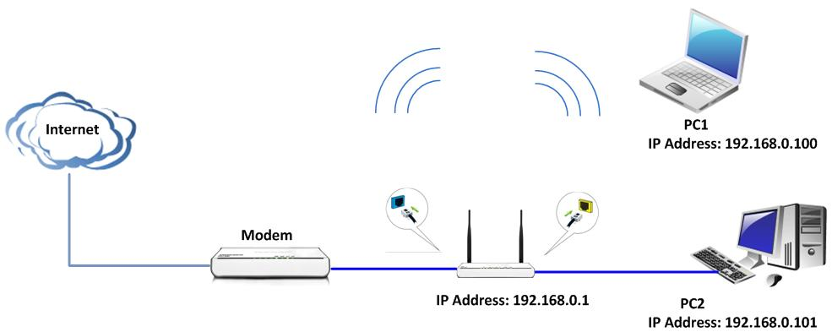
The Steps are as below:
I: set up the router
1. Connect the Device following the topology: the computer connects to the yellow LAN port on the router with Ethernet cable, the blue WAN port of the router connects to the modem’s LAN port with Ethernet cable.
2. Login to the router’s home page.
3．Click Setup Wizard to choose the connection of yours (for example: DHCP) and click Next.
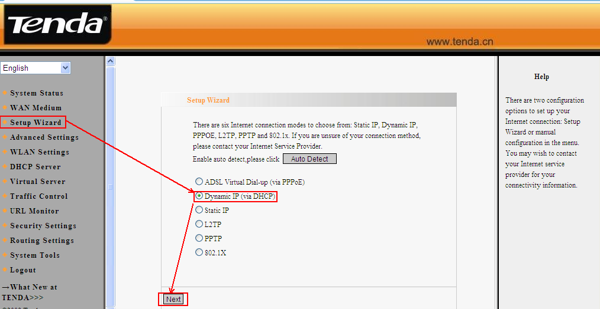
4. Click Apply to save the settings
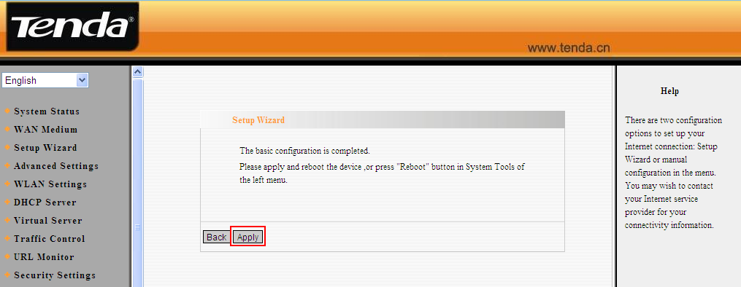
5. Please click System Status to check whether the router has connected to the Internet Successful.
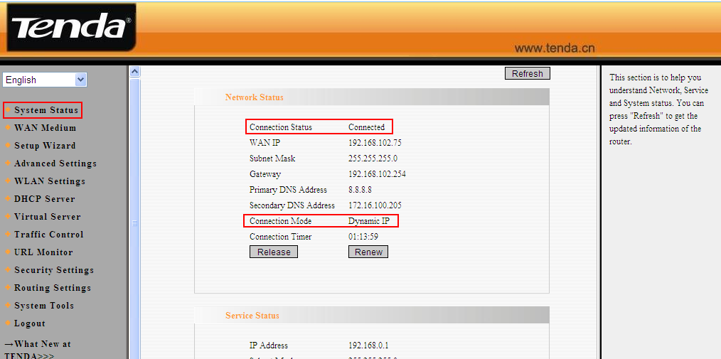
Note:
- When the Connection Status shows Connected, and the router gets the WAN IP, it means that you can access the Internet.
- When the Connection Status shows Disconnected, it means that there are some problems with the WAN Connection. please check hardware connection
- When the Connection Status shows Connecting, please try the steps as below
- Click Advanced Settings→MAC Address Clone to clone your computer’s mac address to the router’s WAN port, then click Apply to save the setting and the router will reboot.
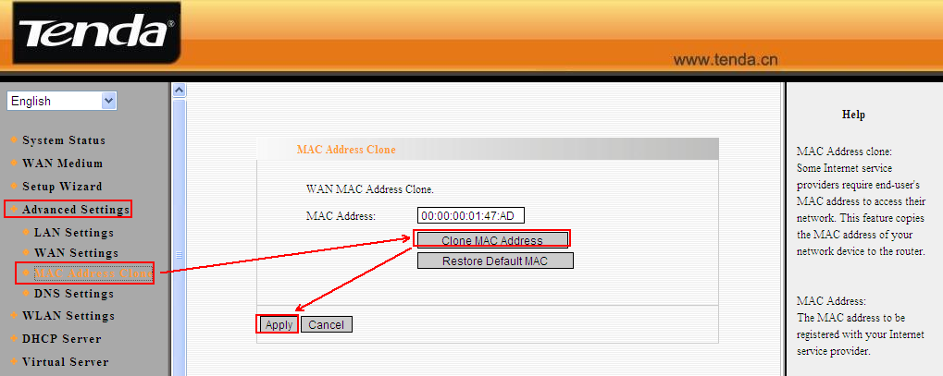
- Click Advanced Setting→LAN Settings to change the LAN IP address from 192.168.0.1 to 192.168.10.1, then click Apply to save your setting and the router will reboot.
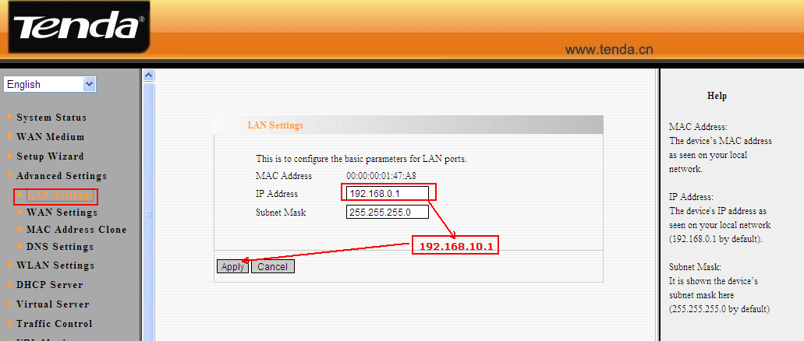
- If the Connection Status is still Connecting, please power off the modem and router and power them back on to check connection status.
II: set up wireless
- Click on WLAN Settings, then click on wireless basic settings, in the middle page main SSID (please change it to your family name) and channel (please choose channel 1 or 6 or 11)
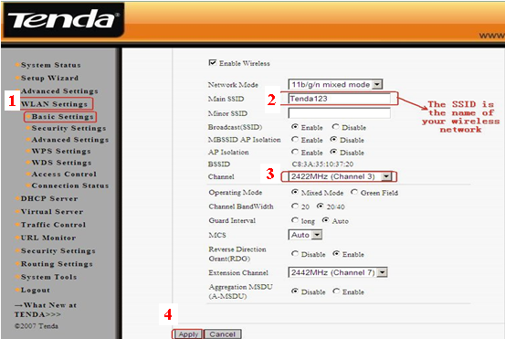
- Go back to WLAN settings, click on security settings, in the middle page , find security mode(select WPA-personal),then find WAP Algorithms( please choose AES), then find passphrase( please type in at least 8 numbers or letters, it is the password or security key for your wireless network ,so you should remember it .After all the settings, please clicks Apply.
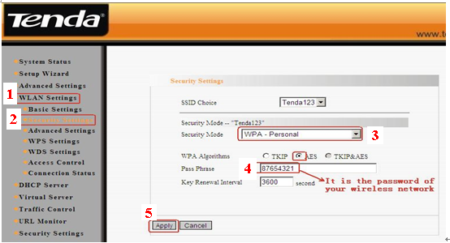
- Go back to WLAN Settings, then click on WPS settings, in the middle page, click on save. 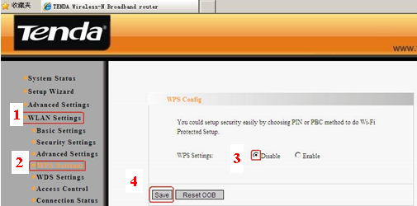
III: connect computers to Internet wirelessly.
Please find the name of your wireless network (it is SSID which is your family name) and connect to it. It will require you to input password, please type password (It is the passphrase which was made by yourself just now.)
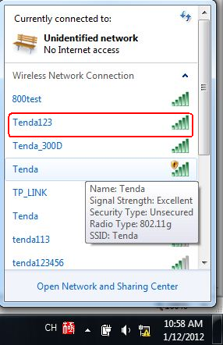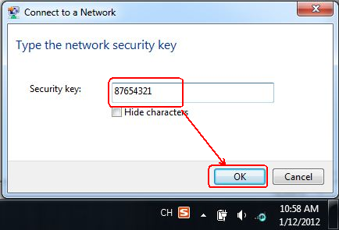
When the SSID (wireless network) shows connected, that means you can access to the Internet wirelessly, now you can try to unplug the cable between your computer and your Tenda router to see if you can enjoy your Internet wirelessly.

